**Batch: B4 (IAI-2) Experiment Number:8**

**Roll Number: 16010421119 Name: Aarya Tiwari**

**Aim of the Experiment:** To implement Decision Tree Algorithm (ID3 using library)

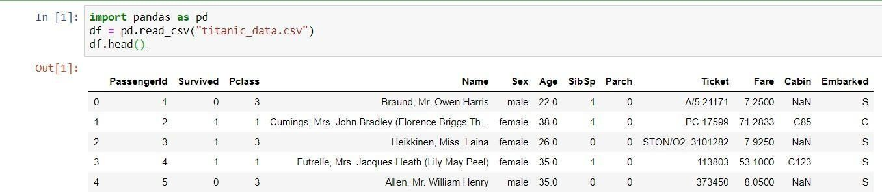**Program/ Steps:**

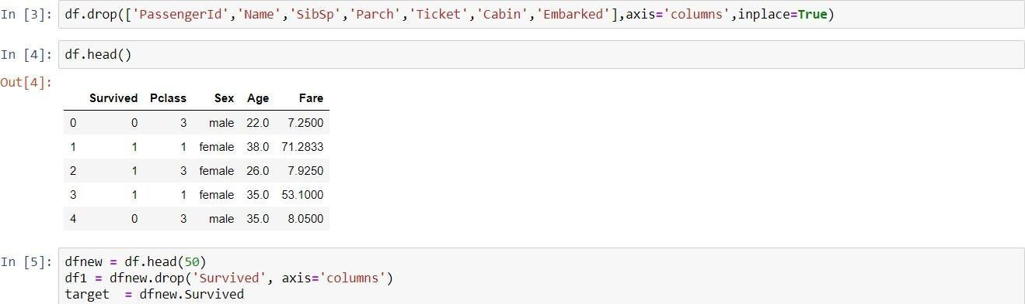

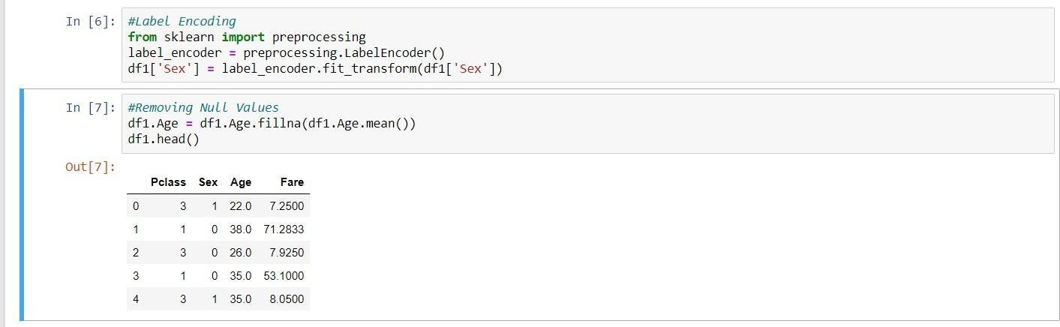

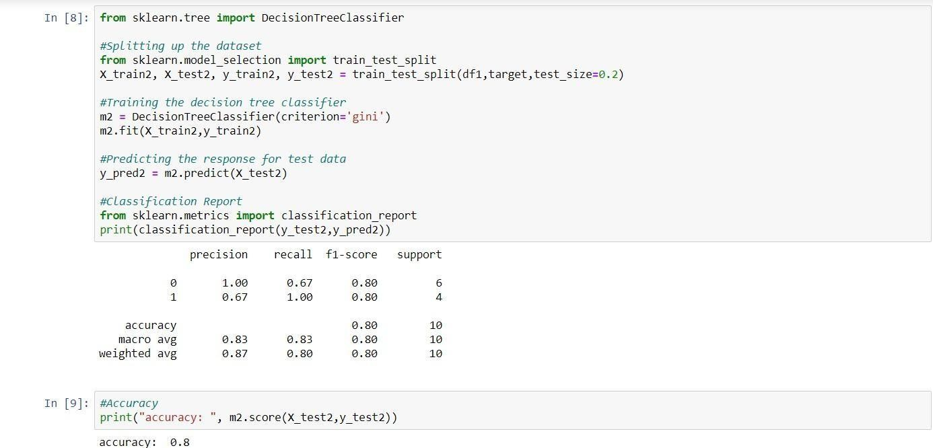

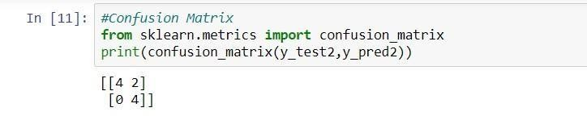

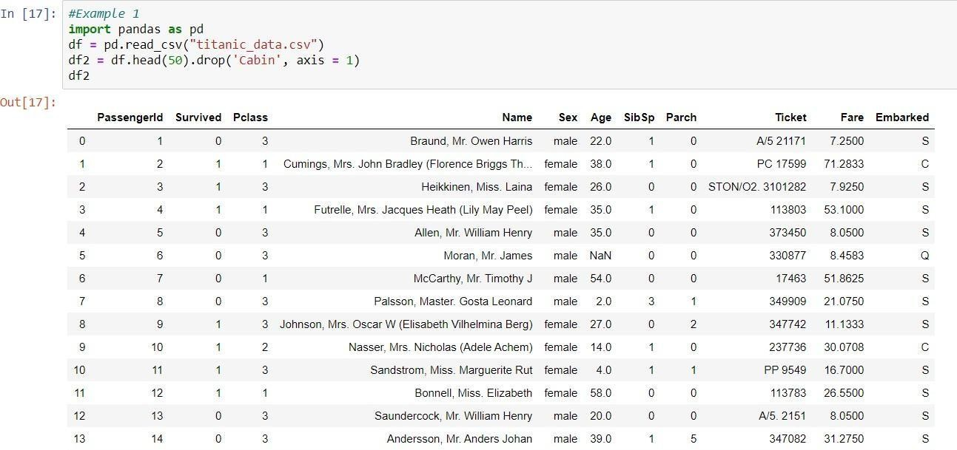

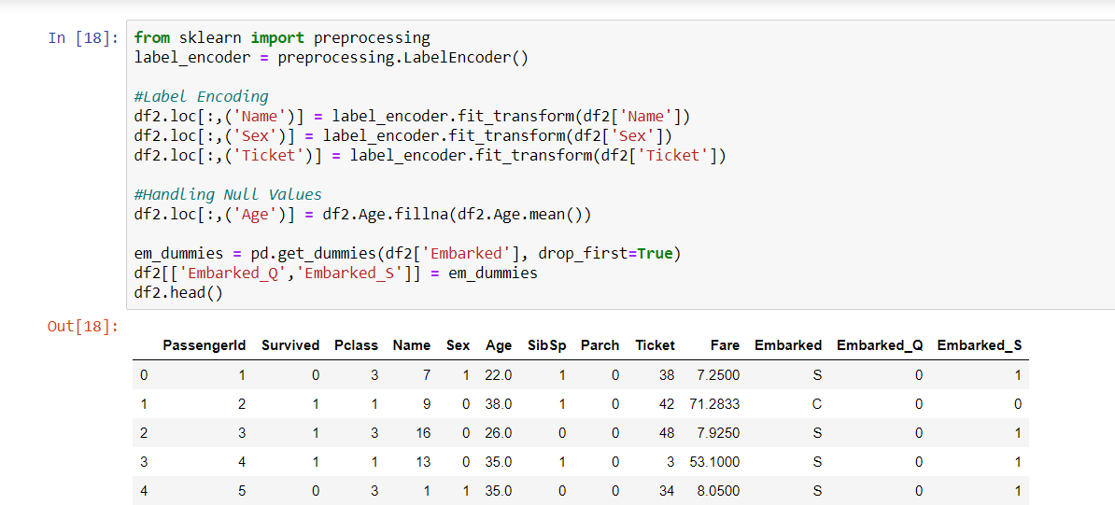

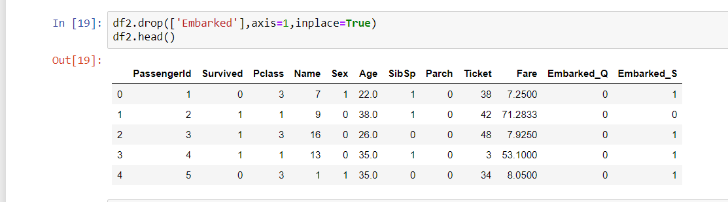

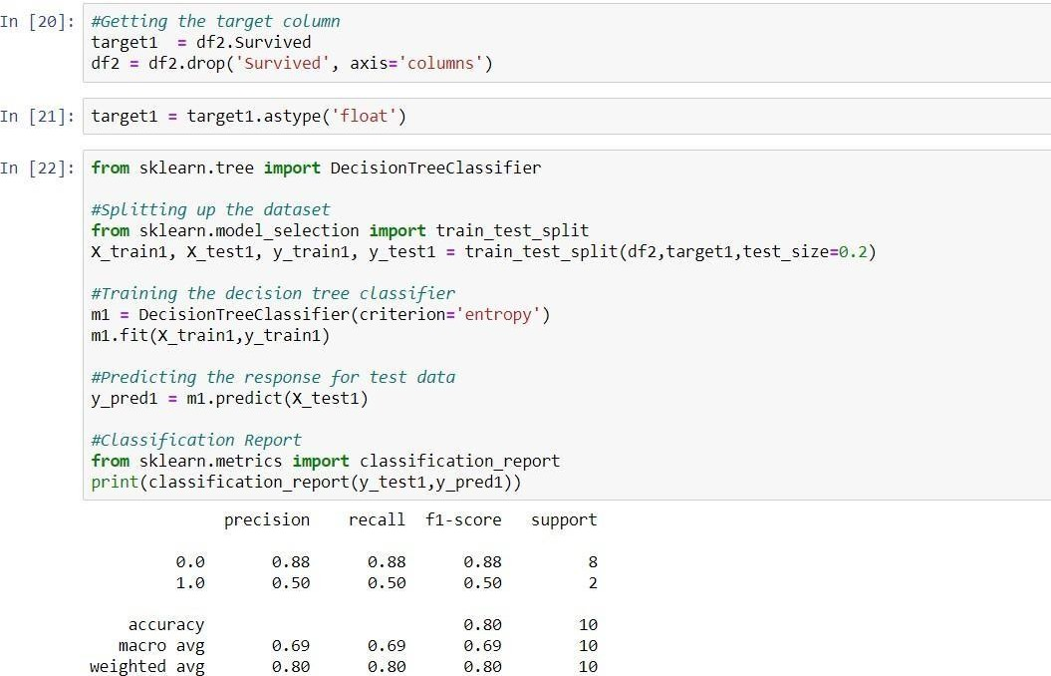

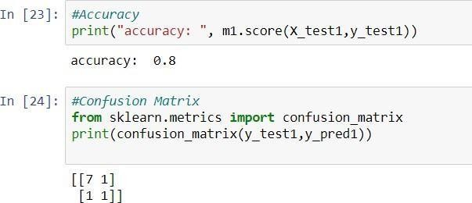

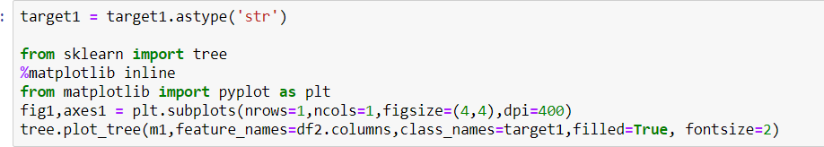

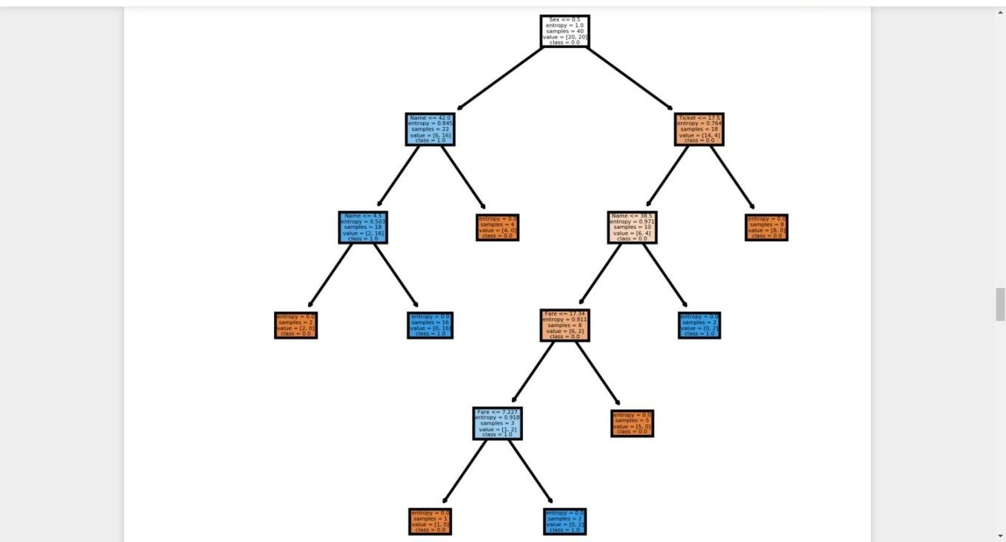

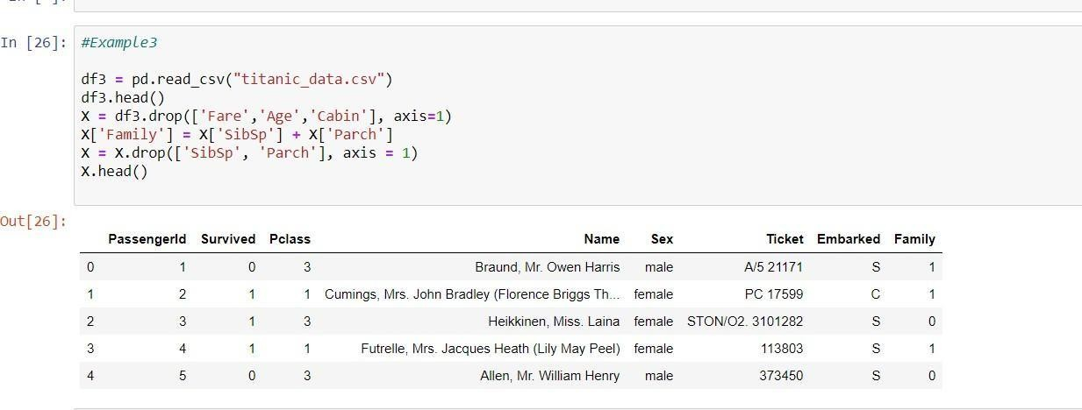

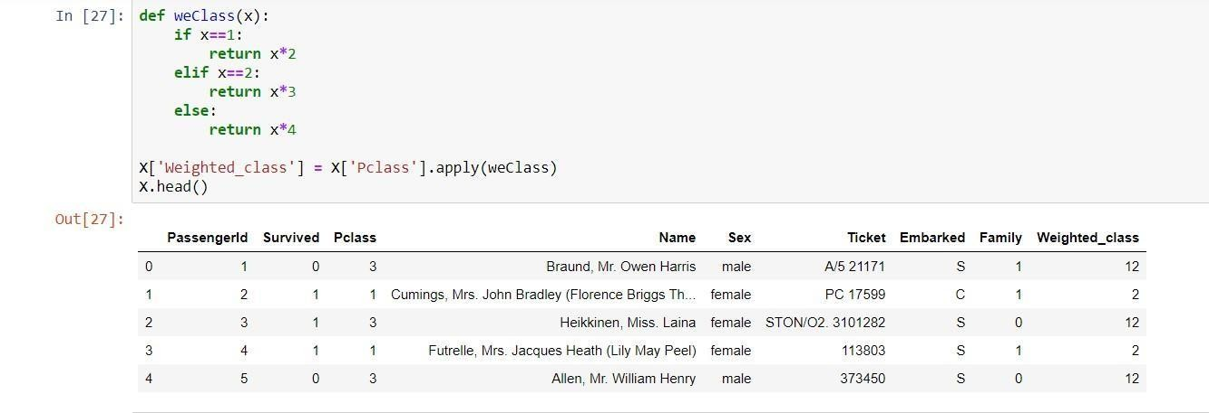

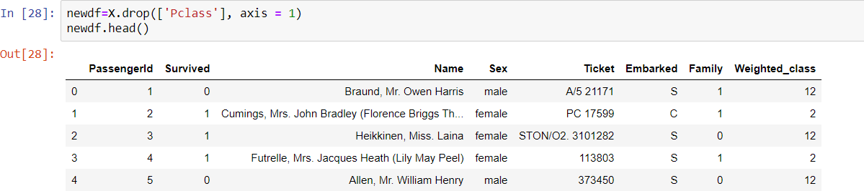

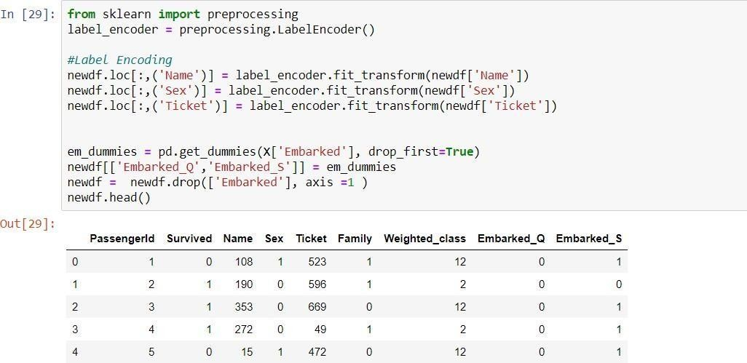

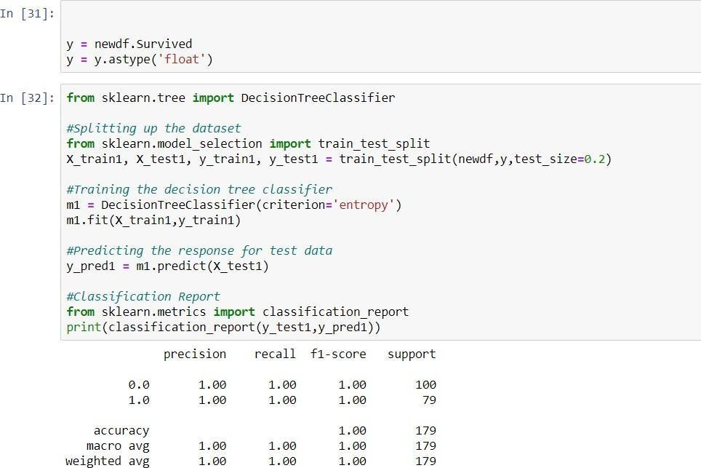

KJSCE/IT/SYBTECH /SEM IV/IAI/2021-22

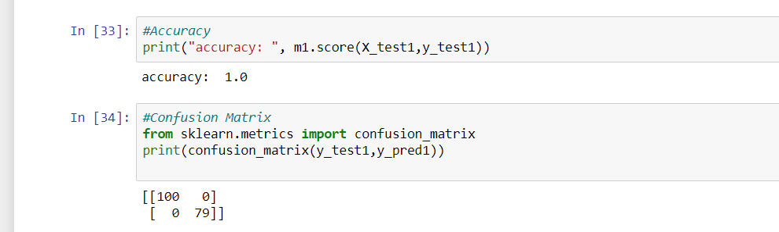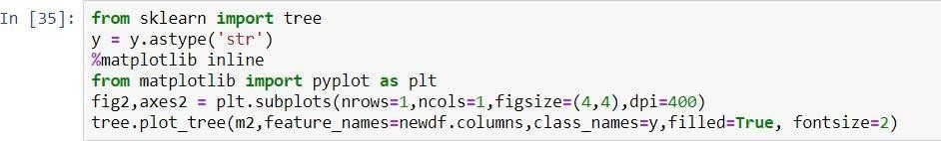

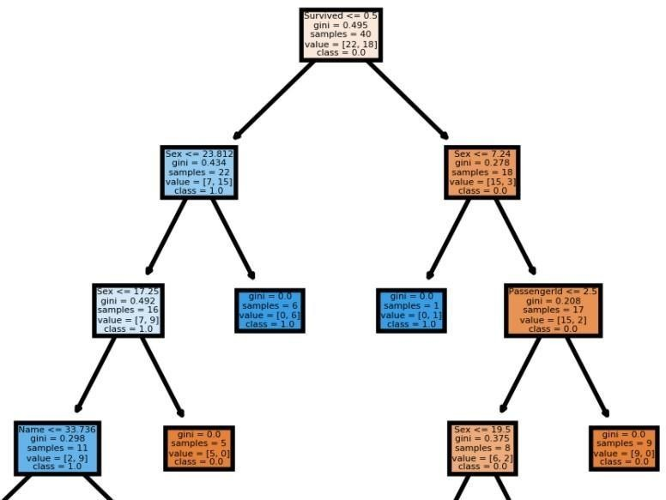

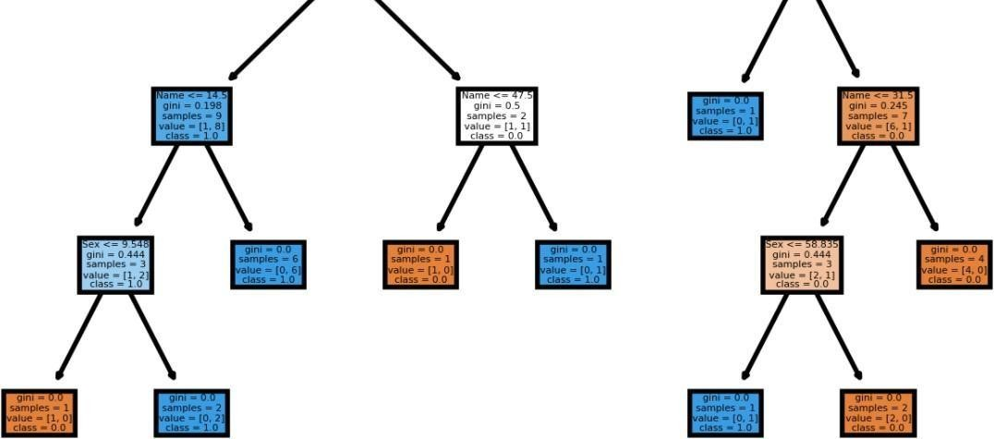

**Outcomes:** CO 5: Understand fundamentals of learning in AI

**Conclusion:**

We learnt how to make a decision tree and test data and accuracy of that decision tree



**References:**

* Stuart Russell and PeterNorvig,ArtificialIntelligence:AModernApproach,Secon d Edition, PearsonPublication

ElaineRich,KevinK night,ArtificialIntelligence, TataMcGrawHill,1999